General Policy Doc

General Academic Policies of Ashoka University
Drafted by the Policy and Resources Department of
Ministry of Academic Affairs 2025-26
Date of Completion of Draft: 11/02/2026
Date of Approval by OAA: 12/02/2026

Notes:
- In this document, the intake year is the year used for batch specifications.
- Credit requirements for degree credentials (major/minor/concentrations) are SEPARATE from credit requirements of degree (overall graduation requirements).
- This document only entails the general academic policies. Subject specific policies like cross lists, ISMs, research thesis, among others will be shared with updated subject handbooks soon.
- Please refer to the index on the left side to navigate to a particular section you wish to read.

Audit Policy
To audit a course means to attend and participate in a class without receiving a formal grade or earning academic credit. Whether a course allows audit students or the requirements of audit in a course is completely decided by the faculty.
- Auditing Courses
- Students cannot audit courses in their first semester and the summer semesters.
- From the second semester, students may audit up to two courses per semester over and above the maximum number of credits that they are otherwise allowed.
- Auditing a course does not yield credits; however, the audited course will show on the student’s transcript and require that the student submit work as determined by the faculty member. It will reflect as ‘AU’ on the transcript after successful completion of the course.
- If a student wishes to audit a given course, they must submit an audit request to the faculty through the AMS Portal. (You can talk to the respective faculty/Teaching Fellow or read the course manual to understand the audit requirements of a course)
To submit an audit request: AMS→ Course Registration → Audit Registration Form.
- Students may withdraw, without consequence, from a course that they audit by the end of Week 4. Those who drop an audit after Week 4 will get a WAU notation on their transcript. Those who do not fulfill the audit requirements specified by the faculty will have the audit removed from their transcript.

- Credit to Audit Conversion
- If during the semester, a student realizes they wish to drop a course for credit, but still want to be part of the course and engage with it, they can request to convert their status from ‘enrolled for credit’ to ‘enrolled for audit’.
- The deadline to convert credit to audit is the end of week 8 of the semester. A student cannot convert their status in a course to auditing status past that deadline and they cannot convert any course from credit to audit if, by doing so, they will fall below the minimum credit requirements, i.e. 16 credits per semester.

Note: 1) Audit to Credit is typically not allowed. It can be done during the first four weeks of the semester where you drop your audit. If it is in the first two weeks, you can directly take the course for credit from AMS, or if it is in the third or fourth week, you can take the course for credit only if the faculty agrees. However, audit to credit is subject to availability depending on the course cap.
2 ) For Credit to Audit,
- If the portal is open (during the Add/Drop period i.e. First Four weeks of the semester), one can drop the course via the AMS and fill in the Audit form.
- if the portal is closed, raise a ticket via the AMS with the faculty's approval within the add/drop period.

What is Shopping Week?
Each semester has the first 2 weeks as shopping weeks (which means that you can add or drop a course without informing faculty through AMS). Please refer to the below table for a clear understanding. If you decide to drop a course between weeks 5-8, it gets reflected as ‘W’ on your transcript. If you withdraw from a course between weeks 9-14, you get a ‘WF’ on your transcript.

Add Course
Week 1-2 | Add a course without  permission
Week 3-4 | Add a course only if  faculty agrees
Drop Course
Weeks 1-2 | Self-drop without permission
Weeks 3-4 | Drop after informing faculty  Withdraw from Course
Withdraw from Course
Weeks 5-8 | Withdraw after informing  faculty; a ‘W’* will show on the transcript
Week 9 and later | ‘W’ with F** (fail notation) or X***  (exceptional circumstances  notation)
* W no effect on CGPA
** WF is equivalent to an F grade and impacts GPA
***WX granted only in case of LOAs. No effect on GPA.

What is the process of taking courses for credit in the third and fourth week?
You need to approach the faculty and get an approval on mail from them for joining the course in the 3rd or 4th week. Subsequently, you need to request them to ask the OAA to add you or you can email OAA attaching the screenshot, to get added to the courses.

Incomplete Policy
‘I grades’ should be granted by faculty only to students who have been working throughout the semester and only near the end face sudden illness or injury, family crisis, or some other substantiated unforeseen circumstance beyond the control of the student that would make it impossible to complete all course requirements by the end of the semester. Students who are not deemed eligible may still request OAA for a WF and repeat the course at a later time. ‘WF’ has the same impact on CGPA/GPA as ‘F’ does. This request must be made in the 13 weeks of the semester i.e. last day of the class as per the academic calendar. After that, the grades decided by the Faculty will be considered as final.

- Application for an Incomplete
- Students who believe that they can demonstrate a legitimate need for an Incomplete should:
- request their faculty to grant them an Incomplete
- request their faculty to clearly specify the terms of the Incomplete

- Deadline for submitting an Incomplete
For all batches before UG2024, i.e. UG2021-UG2023 students, the deadline for completing the process specified above is the last day of finals week of the semester.

For UG 2024 and UG 2025, while the ideal deadline for completing the process specified above is the last teaching day of the semester, as specified in the Academic Calendar; the student must coordinate with the faculty/TF to know by when they can request for an incomplete because cases may differ if the faculty decides to conduct early final exams or otherwise.

- Conditions and Duration
- For UG2023 and previous batches
Unless the instructor stipulates a shorter time period for completion of the work, the terms of the Incomplete must be satisfied within six weeks of the beginning of the regular semester following the semester in which it was issued.
Incompletes from a previous semester will automatically convert to an F grade at the end of week 8 (six weeks plus two weeks for grading) unless a request for an extension has been approved by the faculty and implemented by the OAA. This extension deadline must also be shared by the faculty to the student as well as the OAA.
For example, if you get an incomplete grade granted at the end of Monsoon semester, you must submit the expected coursework within the first 6 weeks of the Spring (which is the next immediate) Semester.

- For UG 2024 and UG 2025
Incomplete must be satisfied within eight weeks of the end of the regular semester in which an ‘I’ was granted.
Incompletes from a previous semester will automatically convert to an F grade at the end of Week 8, counting from the end of that semester in which Incomplete was granted.
For example, if you are granted an incomplete grade on 13th May of spring semester (assuming that is the last day of that semester), you will have to satisfy the requirements 8 weeks from 13th May (which will go on into the summer break). Similarly, if you were granted an incomplete grade on 8th December (assuming this is the last date of the semester) of monsoon semester, you will have to submit the required work 8 weeks from 8th December, which will include time within the winter break and even into the Spring semester.

The maximum extension that can be granted is the end of the next semester, after which no further extension will be approved by the OAA and the ‘I’ will change to ‘F’. Taking the above example of 8th December (assuming it is the last day of the Monsoon semester) of Monsoon semester; even if a student gets an extension to submit their coursework for the incomplete grade till the end of Spring semester, they must submit it before the last date of Spring semester or they will get ‘F’ reflected on their transcript. Note that any extension granted above the six weeks deadline is totally circumstantial and will be decided by the professor who can then write to OAA to get this extension approved.

- Prerequisites and Graduation
As long as an ‘I grade’ remains on their record for a specific course, a student may not be enrolled for credit in any course which has that specific course as a stated prerequisite. This will vary from department to department. Any waivers in this case have to be taken up with the concerned faculty and the OAA.

Note: A student who has completed all the graduation requirements within the stipulated time, will not be allowed to defer graduation because of the Incomplete. Such an Incomplete will be converted to a 'W' grade and the student will be marked as 'Graduated'.

Grade Comments

AU: Course Audit. Awarded to students who successfully audit a course without earning any credits.

I: Incomplete. May be granted to students who were unable to complete coursework by the end of the semester. Failure to complete the coursework and earn a grade within a stipulated time results in a failing grade (F).

P: Pass. The student successfully completed the course and received credits. No effect on the GPA.

TC: Transfer Credit. Awarded to students who completed courses at another university. Credits are transferred, but grades earned neither affect the GPA, nor are shown on the transcript.

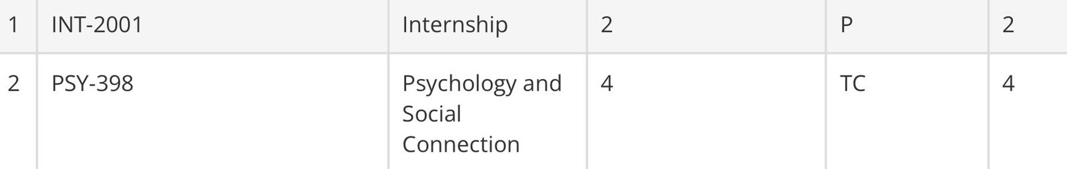
This is how a TC (Transfer) and Internship credits would look on your transcript.

TP: Teaching Practicum. Awarded to students who assisted a faculty member in a course.
W: Withdrawn. Assigned to students who withdrew from a course between Week 5 to Week 8 of the semester. No effect on the GPA.
WAU: Withdrawn from Audit. Assigned to students who withdrew from an audited course. No effect on the GPA.
WF: Withdrawn (Fail). Assigned to students who withdrew from a course beyond Week 8 of a semester. A WF has the same effect as an F.
WX: Withdrawn (Exceptional). Assigned to students who withdrew from a course after the last date for withdrawal due to exceptional reasons, e.g. severe illness. No effect on the GPA.
Gap Semester: Semester in which no courses were taken or all courses were dropped. Depending on which stage of the semester a LOA is requested, the student may get a "WX" in all courses: the semester will then remain on the transcript.

Internship Policy [Last Updated based on Rules shared on 11 June 2025]
As per the four year program structure under NEP, UG2022 and further batches need at least 2 internship credits to graduate. Internship Credits can be earned after completing 2 full semesters at Ashoka. (You cannot earn internship credits till the end of your first year, with the only exception of UG2022 (Any internships undertaken by UG2022 in their first 2 semesters will also be accepted as per the rules regarding time period defined by the OAA). This means that you can start earning the internship credits from the first summer of your degree.

The following table has been taken from the Internship Process Document shared by OAA over email:

Course Code | Reference (for Internal use only) | Credits/Grades | Process
INT-2001 | Self-Outside Ashoka | Credits are determined by the number of working days. P/F grade only | 1. Apply through AMS, via “Manage Internship” 2. At the time of completion, students will Mark as Completed and upload the completion certificate.  3. An automated email will go to Mentor for verification
INT-2002 | Through CDO-Outside Ashoka
INT-2003 | Under an Ashoka Faculty | Credits and grades are determined by the faculty, subject to their not violating the Ashoka University Internship Credit Policy | 1. Apply through the Internship Portal  2. The application will be accepted by the concerned faculty/office/centre via AMS  3. At the time of completion student will Mark as Completed  4. Credit and/or Grade will be provided by the faculty/office/centre via AMS
INT-2004 | Under an Ashoka Department/Centre | Credits are determined by the number of working days. P/F grade only
INT-2005 | As ISM | Credits and grades are determined by the Ashoka faculty | End of Semester, after getting grades, these reflect in your internship portal
INT-2006 | As TP | Credits and grades are determined by the Ashoka faculty
INT-2007 | GESP-Outside India | Credits are determined by the number of working days. P/F grade only | Same as INT-2003 or INT-2004

Only 2 internships with P grades and upto 4 credits would be counted. Minimum 2 credits and maximum 4 credits will count towards satisfying NEP requirements (for 2- and 3-year exits as well as 4-year degrees) for students in the new four-year programme (2022 intake and thereafter).
The internships could be within Ashoka (Under a Faculty/With a Department/Centre) or outside Ashoka (Through the Career Development Office (CDO)/Self-arranged (India/Abroad)/Through the GESP Office), or a student can convert a graded ISM/TP into an internship.

Note: TAship also has a letter grading system and the rubric for the same is subject to department and the faculty. In case your internships are letter graded, 2 internships with the best grades up to 4 credits will be considered.

Definition of internship semester as per the UG calendar:
a. If the start date of the internship lies in the Spring semester, the internship semester will be recorded as a Spring internship.
b. If the start date of the internship lies after the Spring but before the Monsoon semester, the internship semester will be recorded as a Summer internship.
c. If the start date of the internship lies in the Monsoon semester, the internship semester will be recorded as a Monsoon internship.
d. If the start date of the internship lies after the Monsoon but before the Spring semester, the internship semester will be recorded as a Winter internship.

As per the Ashoka University Internship Credit Policy, the number of credits is calculated as follows:
a. 2 Credits: Between 20 to 39 working days (Mon-Fri)
b. 4 Credits: At or above 40 working days (Mon-Fri)

Ashoka Internship Policy assumes part-time work only in the Monsoon or Spring semesters. Any internship during summer or winter break is assumed to be full-time.

Your TAship credits can also qualify for internship credits when registered with AMS. However, in this case they will only be counted once and will not count for TAship credits then.

These credits count towards credit requirements for degree and not towards any major/minor/concentration.
For example, if a Political Science TAship yields 4 credits but you get it registered as an internship on AMS, then those 4 credits will count towards your internship credits and not count towards your Political Science credential (major/minor/concentration).

Internship credits earned during the semester will follow the maximum credit policy of that semester. They are counted under non-academic credits.

Note: If you are doing both summer semester and summer internship, you can do up to a total of 10 credits (8 credits from MM and 2 credits from TAship, ISM or Internship). If you are only doing a summer internship, then you can do an internship of 4 credits.

For more details about the process and rules regarding internship credit, please refer to the document shared by OAA via email on 11 June 2025 titled ‘Final Internship Process’.

TA Policy
TAship can be done in the third or fourth year of your undergraduate degree. It can also be done in the summer semester right after the completion of your second year and subsequent summer semester. Doing a TAship would earn you TP grades (as per the professor) that will affect the overall GPA. Some departments consider TAship (Teaching Assistantship) credits for major requirements, while others don’t. Some offer 4 credits for TAship while others offer 2. The only thing that remains constant is:

The policy says “TAship credits only count for elective credit requirements of a particular credential and can't be counted towards fulfilling the mandatory credit requirements.” What does this mean?
- Firstly, TAship credits (if the department counts it as part of the major) can only count towards elective credits and cannot count towards core courses/ credits. This does not mean that you cannot TA for a core course, it only means that your TAship CANNOT be counted towards fulfilling your core/mandatory course requirements, it will count towards fulfilling elective requirements.
- Secondly, whether or not your department gives you major/minor credits for doing TAship, your TAship credits will be counted towards your overall graduation requirements. (Once again, it is important to differentiate between department credits that one needs to complete their major/minor/concentration and overall credits that one needs to complete their graduation requirements).

Q. Is there an upper limit to the number of TAships which can be done in a semester?
Ans by OAA [Dated 5 Feb 2026] : Yes, maximum 4 credits.

Process to register TAship credits as internship credits:
You can convert your TAship to an internship via the internship portal near to your graduation date. The exact date for this will be communicated by OAA.
Suggestion from MAA: Please go through FAQs in the last section of this document for TAship details as well.
The policy, benefits and credits vary across departments.

CC Policy
CC grades are like any other course grading. They are 2 credit courses. A student can take only 1 CC in a semester. All students need to mandatorily do 2 CCs for graduation. The credits earned by doing more than 2 CCs will not count towards the overall CGPA and the overall degree requirements.

Note: Up to 4 credits from 2 Performing Arts Co-Curriculars can count towards your PA minor / concentration.

What are Open Credits?
We know that credit requirements for a degree are different from credit requirements for other credentials (major/minor/concentration).

Assume that one student requires 160 credits to graduate but their major credit requirements are only 72. Now consider that the other requirements for graduation such as FCs, CCs and Internship take up another 42 credits. Still (160 minus 72 minus 42) 46 credits will be left.

Major Credits | 72 credits
Compulsory FC, CC and Internship Requests | 42 credits
Overall Graduation Requirement | 160 credits
Remaining Credits (Open Credits) | 160-(72+42)=46 credits

These are called open credits, which a student can complete doing more courses like minor, concentration among others.

ISMs Policy
An Independent Study Module allows one or more students to spend one full semester working with an instructor on a topic not otherwise offered in the department. It also allows students to delve more deeply into research, either assisting an instructor on a specific research agenda, or in some cases, charting their own research agenda. If and how many ISMs credits can count towards Major/Minor/Concentration requirements is decided by the department. However, the default maximum number of credits from ISMs that can count toward a student’s undergraduate degree is 12 credits. ISMs credits, if allowed by the department, generally count towards the elective requirement of a particular credential. Exceptions, if any, are approved by the Dean of the Academic Affairs.
Q. Can an ISM be cross-listed?
Ans by OAA [Dated 5 Feb 2026]: ISMs cannot be cross listed.

Q. Can an ISM be audited?
Ans by OAA [Dated 5 Feb 2026]: No.

Retake Policy
- The retake policy allows students to retake any courses twice during the course of their 3 year program and three retakes for their 4 year program. Those receiving F/W/WF/WX grade will continue to have the unrestricted option of repeating the course.
- For UG2022 and UG2023, those receiving a grade of D- and above will also have the option of repeating that course but can do so only thrice during their undergraduate program of 4 years. They can take 2 retakes in 3 years and 1 in the last year of their 4 degree program. Please refer to the below table for policies for all batches.
- For UG2024 and UG2025, those receiving a grade between C to D- can retake the course but they can only retake 3 courses in 4 years. They can take 2 retakes in 3 years and 1 in the last year of their 4 degree program, and they can only retake a course once. Unlike for UG2022 and UG2023, where the best attempt gets counted; whatever the grade of the second attempt will be, will get counted towards the CGPA for UG2024.
- A student cannot repeat a course for which they have an unresolved Incomplete grade (I).
- Students who have completed enough credits to graduate within the normal duration of the programme cannot defer graduation to repeat a course.
Policy | Batch
Policy | UG 2021-24 | UG2022-25 | UG2023-26/27 | UG2024-28 | UG2025-29
A student receives the same grade F: no limitations | ✅ | ✅ | ✅ | ✅ | ✅
A student receives the grade D-, D and C-: Can repeat unrestricted number of times | ✅
A student receives the grade C and above: Can retake only twice in their undergraduate journey | ✅
A student receives a grade D- and above: Can retake only thrice in undergraduate journey, with no more than two repeats in the first 3 years |  | ✅ | ✅
A student receives a C grade or below: They may retake the course only once, and the grade on the second attempt will be counted. This option can be exercised only three times during the UG programme, of which no more than two repeats will be granted in the first three years. |  |  |  | ✅ | ✅

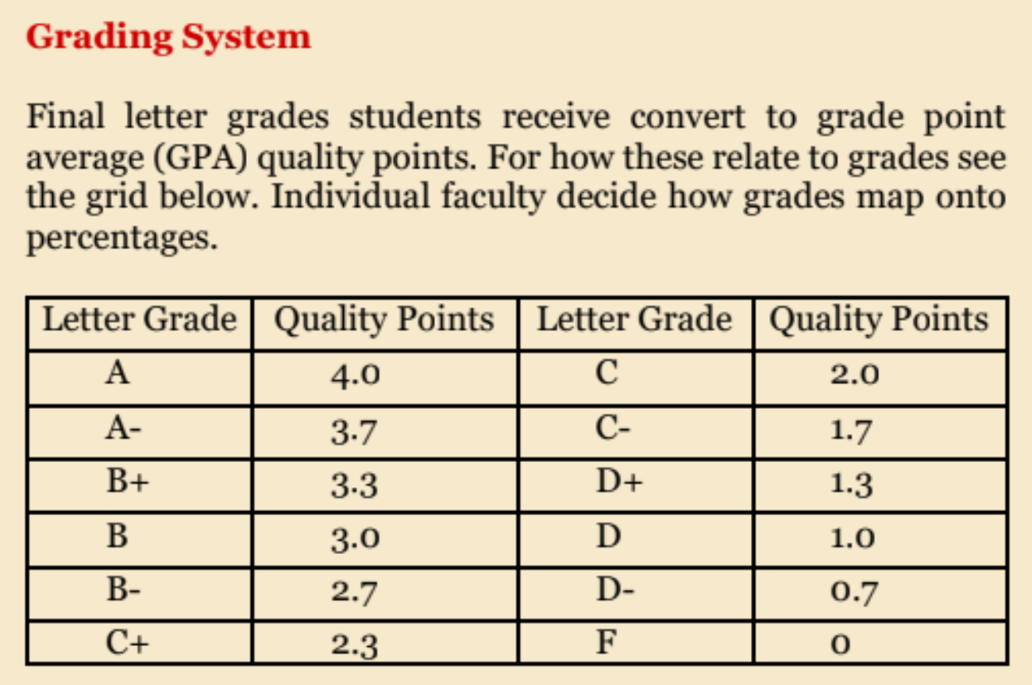
Q. Can a student transfer unused retakes from the 3 years to the 4th year?
Ans: If a student has not taken a retake till 3 years then the student can take it in 4th year. [Reply from OAA | Dated 3 Feb 2025]
Q. What is the cap on the number of retakes which can be taken in one semester?
Ans: There is no such cap [Reply from OAA | Dated 3 Feb 2025]

Dean’s List
In every regular semester, undergraduate students who have completed at least 16 undergraduate academic credits in a given semester, who have not taken a Pass/Fail option in that semester, and whose GPA in that semester is ≥ 3.65 make the Dean’s List in that semester. The semesters in which a student makes the Dean’s List will be marked on the transcript, and students who make the Dean’s List by the end of the regular semester will be notified about this by the Dean of Academic Affairs.

Waivers Policy
Pre-requisite courses are usually core courses for your particular major/minor degree which you need to complete before you can take higher level courses or electives. Their codes usually start with 1000 level (Eg. POL 1012) and need to be taken before courses with 2000 or 3000 level codes. While making your trajectory, please keep in mind that you need to finish your pre-requisite courses as early as possible. You can refer to the list of core courses in your respective subject handbooks, also available in the MAA Resources Folder.
There are three types of waivers-
- Prerequisite Waiver: If you're switching your major or adding a new minor but haven't done any introductory courses from that programme, you may need a waiver to take a course without the required prerequisites. However, you'll still have to complete those prerequisites in future semesters. For example, if you want to take "Introduction to Literary Theory" but haven't done "Forms of Literature," you'll need a waiver, but you must take "Forms of Literature" later. The granting of such a waiver may vary from department to department.
- Equivalent Waiver: If you've already taken a course in another department that covers the same material as a required course in your new major, you can get an equivalent waiver, meaning you don't need to take the same course again. For example, if you've completed "Statistics for Economics," you can waive "SRM-I" in Psychology.
- In Lieu of Waiver: If you're struggling with a required course or can't complete it on time, you can request to take a different course as a substitute. The alternative is chosen by the department head and could be another core course or an Independent Study Module (ISM). This, however, is an exceptional case waiver and completely depends on departmental and Dean’s approval.

Grade Appeal Policy
A student can appeal only the final grade of a course under certain circumstances.
The instructor’s academic judgment about the quality of a student’s work is not negotiable.

- An appeal may be made if the student can show that the grade grossly violates the instructor’s grading policy or was awarded in a manner that is arbitrary and discriminatory.
- Calculation error is a valid ground for appeal.

Grade appeals submitted for any other reasons, like some mentioned below, will be DECLINED:

- Because the student judges that their grade does not reflect how hard they worked.
- Because the course instructor denied them an academic accommodation that impacted their grade (barring academic accommodations approved by the Office of Learning Support).
- Because their CGPA falls below a threshold necessary for admission to another Programme.

To lodge a grade appeal, students must use the Grade Appeal Portal on AMS and provide all the necessary information. They must provide a complete explanation of the error in their grade: for example, they can document the grading rubric of their course by submitting a copy of the exam/syllabus or evidence for the grading rubric communicated to students elsewhere; or give a detailed and specific explanation of the error in their grade.

They must submit their grade appeal through the Grade Appeal Portal within the prescribed deadline shared by the Office of Examinations (OOE) and the Office of Academic Affairs (OAA) through mail earlier.

A committee consisting of the Head of the Department, the Controller of Examinations and the Dean of Academic Affairs will evaluate all appeals. The deadline for results of the grade appeal is informed by the Office of Examinations (OOE) by mail.

Please note that the Committee's determination is final and binding on the student, and that their grade may remain the same or be higher or lower. If a graduating student makes a grade appeal, in case the grade gets revised, the transcript shall get revised later on. Note that the Grade appeal portal is not applicable for graduating students, they have to directly reach out to the faculty if they are in their final semester for any grade revision.

Note: For any queries regarding grade appeals, you must write to the Office of Examination and not the OAA.

Leave of Absence Policy

- A semester of LoA for a student is a regular semester (Monsoon or Spring) (i) during which they are not enrolled for any courses, or (ii) from which they withdraw before the end of the semester after initially enrolling for courses.
- When a semester of LoA can be granted: A semester of LoA is granted for one whole semester at a time. It may be granted for one of the following reasons:
  - medical difficulty;
  - family difficulty;
  - temporary employment of any kind;
  - any other reason with the approval of the Dean of Academic Affairs.
- Under normal circumstances, an undergraduate student may apply for at most one semester of LoA for one academic year of their programme. Thus, undergraduate students exiting with (a) a certificate can avail of at most one semester of LoA, (b) those exiting with a diploma can avail at most two semesters of LoA, (c) those exiting with a three-year bachelor's degree can avail at most three semesters of LoA, (d) those exiting with four-year bachelor's degree can avail at most four semesters of LoA.
Exceptions may be granted by the Vice Chancellor.
- How to apply for a semester of LoA:
  - To request a semester of LoA, a student is required to apply to the Office of Academic Affairs (OAA). A student wishing to take two or more semesters of LoA successively must apply for each semester separately.
  - A student applying for a LoA will normally be required to provide proof that they have support of their guardian. Proof of support by the guardian is mandatory in all scenarios, if the student is applying for the last allowed semester of LoA in their degree programme ; in this case, they must also make the undertaking given in the appendix below.
  - In exceptional cases, the Dean of Academic Affairs may allow a student to apply for a semester of LoA without supporting documents from their parents or guardians. For any exceptional circumstances, please reach out to OAA.
- Once the application and all supporting documents for a semester of LoA have been received, it will be processed at the OAA and approved — where allowed by the rules — by the Director of the OAA. If a student applies for two or more semesters of LoA successively, approval will normally be granted for one semester at a time.
- When a student is on LoA, they are not permitted to reside in the residence halls or off-campus housing of Ashoka University. Once a semester of LoA is granted to a student, they must immediately vacate the residence facilities allotted to them for the remainder of the semester. Exceptions may be made by the Vice-chancellor.
- Depending on when the request for LoA is received, it will be recorded in one of the following ways:
  - If the request for a semester of LoA is received within eight weeks of the beginning of the semester and subsequently granted, the OAA will update the student’s status to LoA, remove them from all courses they are enrolled in, and inform their instructors. The semester will not appear on their transcript.
  - If the request for a semester of LoA is received after eight weeks from the beginning of the semester but before they have received a grade in any of their courses, the student will be withdrawn from all courses with the grade WX. The instructors will be informed about the LoA. In this case the semester will appear on the transcript.
  - If the request for a semester of LoA is received after they have received grades for any of their courses, the grades for those courses will appear on their transcript. The grades for the other courses will be recorded as WX.
- Courses taken outside Ashoka University or internships done, either at Ashoka University or outside, during a semester of LoA are not eligible for credit or credit transfer towards any Ashoka University programme.
- Warning: maximum period allowed for completing degree includes LoAs: A semester of LoA is included in the maximum period allowed for completion of a degree, which is normally n+2 years for a degree whose stipulated duration is “n” years. Thus, for example, a student in a four-year degree programme is required to complete their degree within six years, whether or not they avail of LoA within that period. A student availing of a LoA is responsible for completing their degree requirements within the maximum allowed time and may not use it as a reason for asking for further extensions.
- Before the end of a semester of LoA a student is required to inform the OAA for reinstatement as a regular student. This should be done at least two weeks before pre-registration for the following semester begins, so that they can participate in it.
- Holding fee: If a student applies for a semester of LoA within four weeks of the beginning of the semester, a holding fee of Rs 20,000/- will be charged in lieu of tuition fees for the semester; in addition, fees for the hostel and other facilities will be charged on a pro-rata basis. If a student applies for a semester of LoA later than four weeks of the beginning of the semester, tuition and hostel fees will be charged on a pro-rata basis.

Sports Accommodation Policy

A request for accommodation should be made at least two weeks in advance, to the Department of Sports of the Office of Student Life. It must then be verified by them and passed on to the Director of the Office of Academic Affairs (OAA) at least one week before the absence for which accommodation is sought.

Under normal circumstances, accommodations will be granted only for inter-college sports festivals, all-India inter-university events, zonal, state-level, and all-India events, international tournaments, and open invitational tournaments (including marathons). Exceptions may be made under special circumstances by the Dean of Academic Affairs, on the recommendation of the Sports Department.

The Director of the OAA will verify that the applicant has a current CGPA of at least 2.5. Applicants who do not satisfy this condition will not normally be eligible for sports-related accommodations. Exceptions may be granted by the Dean of Academic Affairs.

A sports-person representing the university may be granted a maximum of three additional excused absences for the purposes of representing the university over and above the three excused absences allowed to all students.

Once an accommodation request is approved by the Director of the OAA, they will communicate it to the instructors of the courses in which the applicant is enrolled.

Accommodation for missed classes may involve mandatory office hours for the student. This will be decided by the instructor of the course.

No accommodation will normally be made for the major assessment component of the course, which may be a final exam or a final submission. Exceptions to this may be granted by the instructor.

Accommodations for in-term tests and assignments are left to the discretion of the instructor. Two common methods are: (i) giving make-up tests or assignments, and (ii) shifting the weightage so that assessment components for which the student is present carry more of the total weight. This is to be decided by the instructor. We recommend that the instructor state their individual policy on adjustment of assessment for sports-related accommodations in their syllabus.

No accommodation will normally be made for absence during pre-registration and registration.

Maximum Credit Policy
Standard for all cohorts: UG students will be allowed to do a maximum of 16 academic and 2 non-academic credits in their first semester, and 22 academic and 2 (CC/Internship credits) in the following semesters, except in either the 5th or the 6th semester, and in either the 7th or the 8th semester, where students will be allowed to take a total of 26 credits (including CC and Internship).
To explain this better, we can look at the bifurcation below which indicated how a normal semester looks like-
- 5 full courses (or 4 credit courses)
- 1 half course (or 2 credit course)
- 1 CC/Internship (2 non-academic credits)
- A maximum of 2 Audits

Overall Credit Requirements
As mentioned above, overall credit requirements are graduation requirements which are separate from major/minor/concentration requirements. It is the minimum number of credits a student needs to graduate (which is constant irrespective of the major/minor/concentration that they are pursuing), this includes credits from your d disciplines, your FCs, CCs, TAship, ISMs (if any) and internship credits.

For UG2022 and UG2023
OVERALL GRADUATION REQUIREMENT is 114 Credits for three years and 150 Credits for four years.

For UG2024
OVERALL GRADUATION REQUIREMENT is 120 credits for three years and 160 Credits for four years.

For UG2025
OVERALL GRADUATION REQUIREMENT is 160 Credits for four years.

Batch | Duration of Program | Total Number of Credits to Graduate
UG2022 | 3 years | 114 credits
UG2023 | 3 years | 114 credits
UG2024 | 3 years | 120 credits
UG2022 | 4 years | 150 credits
UG2023 | 4 years | 150 credits
UG2024 | 4 years | 160 credits
UG2025 | 4 years | 160 credits

Fourth Year and FCs
All students must complete 9 foundation courses before they graduate.
As per the existing policy, if a student plans to pursue a four year degree instead of three, then they are technically allowed to take FCs in their last year BUT the OAA strongly advises students to complete all FCs by their third year because the OAA has introduced a system that prioritises first and second years for FC courses from Monsoon 2025 onwards. Whilst it is still technically allowed to take FCs in the fourth year, this system will make it more difficult for fourth year students to get seats in FCs.

Degree Rules
Degree rules for each cohort are updated by OAA on AMS (Grades and Evaluations > My Course Report and Degree/Diploma Status > View Degree Credential Requirements). It provides information on the requirements for degree, major, minor, and concentration, and will explicitly tell you what credit requirements you have MET and NOT MET. These rules will help students to understand if their graduation requirements have been fulfilled or not. This option will be enabled by OAA nearer to your graduation time and the timeline for the publishing of these rules will be updated by OAA. If you have violated any policies, it may prevent you from graduating on time.

Pass/Fail Policy
UG2022 and UG2023 can use up to 2 Pass/Fail options in the first three years and 3 in the four year programme for any academic course, but the third Pass/Fail can only be used in the fourth year. A student will have to opt for Pass/Fail strictly during the timeline communicated by OAA over email. If a student opts for Pass/Fail and gets a Pass, the letter grade will appear as P on the transcript. The credits for that course will be counted but the CGPA will not be affected by that course. However, if you fail, you will get an F on your transcript and it will impact your CGPA.
For UG2024 and UG2025, this option does not apply. They can only avail P/F in internship credits, the details of which are mentioned in the internship section.
Note:
- Taking a Pass/Fail during your undergraduate program WILL NOT disqualify a student from Latin Honors if the final CGPA is equal to or above 3.60.
- A Pass does not have any impact on the CGPA calculation.
- For UG2022 and UG2023, if you have one or more unused P/F from your first three years, they can be carried forward to the fourth year. However, a student cannot use more than one P/F in one semester.
- On the basis of grade boundaries, professors decide the final grades, and as per policy D- or above grade reflect Pass grade and F considered as Fail grade.
- If you retake a course and opt for P/F and get P in that course then it will not affect your gpa/cgpa. Once you get a P in a course then you cannot repeat it.
- If one gets a fail grade after opting for a P/F, revaluation leads to a conversion to Pass grade on the transcript (in case the grade lies between an A to D-.)
- If one retakes a course after taking P/F (given they got a F), upon retaking the student will get a letter grade.

Study Abroad Credits
A student cannot go for a semester abroad in their first year. If any student goes to study abroad either in a semester or for summer, they need to be approved by GESP. The courses they wish to take should be registered on AMS under the Study Abroad tab, and should be approved by the department HODs for credit transfer to be possible. The grades for such courses are not transferred and only credits get counted towards your credentials.

Research Credits
How do research credits work? A student planning to do a 4-year degree in research has to earn 12 credits from the research from their chosen Major, which will be included in the Major credits for 4-year degree. For example, if you need to do a total of 92 credits for your major, you can do 80 MM Course Credits + 12 Research Credits. The Research Credits do NOT count towards the minimum or maximum semester credit limit.

Type A and Type B Majors
All credentials which qualify as Majors in Ashoka are classified into type A and type B majors. They have differences in the subject wise number of credits which you are supposed to complete to complete your major. Eg. If you are doing a 3 year degree from the UG2023 batch, you need 114 credits to graduate (these are the overall graduation credit requirements inclusive of FCs, CCs, internship credits et cetera). But among these 114 credits, if you are a type A major you will need a minimum 52 credits for a three year degree while a type B major will need minimum 60 credits for a three year degree.

The current list of type A and type B majors for ALL COHORTS is attached below.

S. No | Majors | Type
1 | English | Type A
2 | History | Type A
3 | International Relations | Type A
4 | Philosophy | Type A
5 | Political Science | Type A
6 | Psychology | Type A
7 | Sociology and Anthropology | Type A
8 | Biology | Type B
9 | Chemistry | Type B
10 | Computer Science | Type B
11 | Economics | Type B
12 | Mathematics | Type B
13 | Physics | Type B
14 | English & Creative Writing | Type B
15 | English & Media Studies | Type B
16 | English & Performing Arts | Type B
17 | Mathematics & Computer Science | Type B
18 | Economics & Finance | Type B
19 | Economics & Public Policy | Type B
20 | Economics & History | Type B
21 | Computer Science & Entrepreneurship | Type B
22 | Psychology & Philosophy | Type B
23 | Philosophy & Computer Science | Type B
24 | History & International Relations | Type B
25 | Politics, Philosophy and Economics | Type B

The detailed list of every major with their split up credit requirements will be provided in the subject handbooks.

The Minimum credit requirements for UG2025, based on Type of Major are:

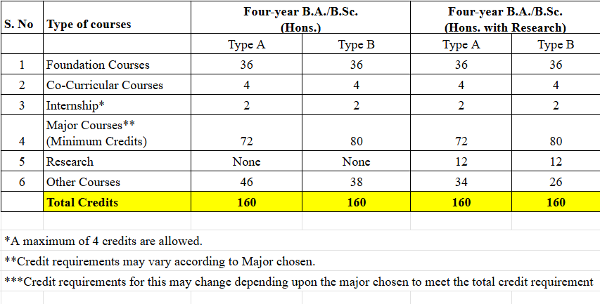

For UG2025, the 4-year degree option is highly encouraged by the OAA. If you have any questions about the credit requirements for the 3-year exit, please get in touch with OAA.
The Minimum credit requirements for UG2024, based on Type of Major are: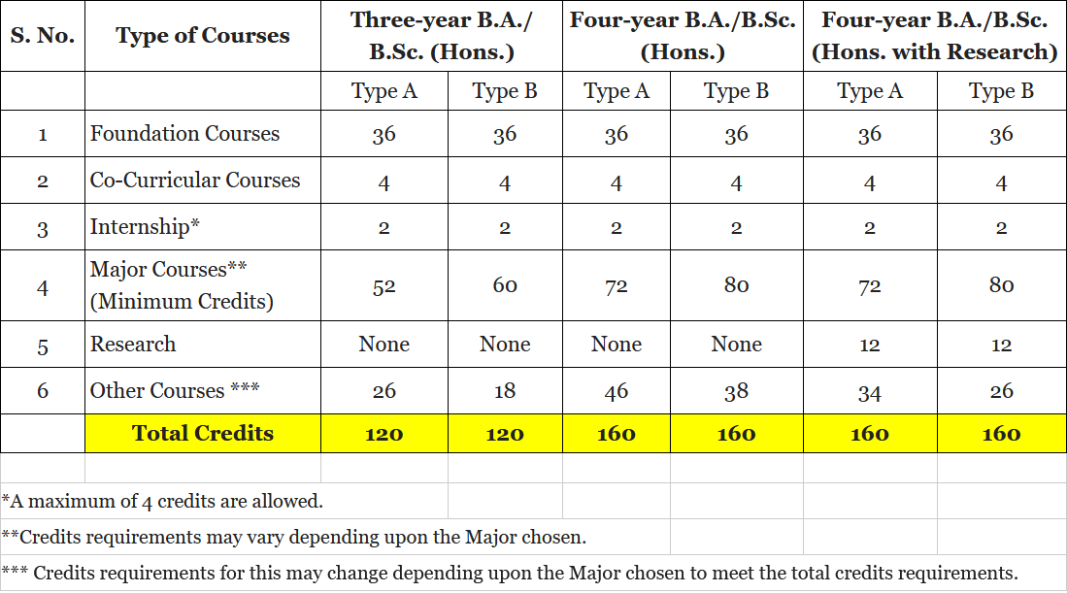

The Minimum credit requirements for UG2022 and UG2023, based on Type of Major are:
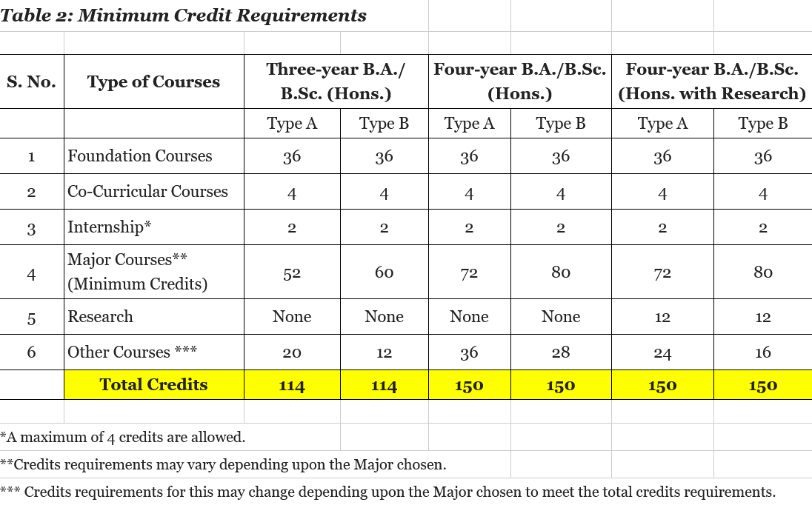

General Cross List Process Interpretation
Terminology:
Dept A xxxx/ Dept B yyyy
Department A is the parent department/ originating department
Department B is the child department

Let’s say a course is being offered by Department A, and you want the course to count towards your credit requirements for Department B. Therefore, the course will be considered a crosslist in your trajectory, since it is being offered by Department A.

For any course to be cross-listed, there must be written approval of both the HODs of the concerned departments and the director of OAA, which reflects as approval on AMS.

For eg-
POL- 3042/ ENT- 2067
POL is the parent department
ENT is the child department
For POL, the course will NOT be considered as a cross list but for ENT it will be.

What if you want it to count towards both ?

If Dept A and Dept B are your major/minor/concentration, it will count towards fulfilling BOTH your credit requirements of major/minor/concentration but it will count only once in your overall graduation requirements.

This is because credit requirements for d credentials (major/minor/concentrations) are SEPARATE from credit requirements of degree (overall graduation requirements).

In POL- 3042/ ENT- 2067, this course will count towards both POL and ENT, and fulfill your major and minor credentials. BUT, you will be one course, i.e 4 credits short of meeting your graduation credit requirement, because instead of doing two separate courses, you’re doing one. That means that a student,who has 8 credits left (for example) to complete the overall credit requirements,will have to take one more extra course of 4 credits,if he takes a cross listing course. This means that you may complete your major and minor but you still won’t be able to graduate because you have not completed the credit requirements in total. Hence, in order to graduate you will to complete the leftover 4 credits by taking up any other course of your choice - this course need not be POL or ENT, because the cross-list course has already granted you your major and minor, so you are free to explore any other course or discipline, the only goal is to complete four more credits to fulfill your graduation credit requirements.

POL- 3042/- ENT 2067 | Pol Credits | ENT Credits | Total Degree Credits
Credits | 4 | 4 | 4 (not 8)
Counted for Cross List Limit | No (because it is the parent department) | Yes (because it is the child department)

Note: Please read the limitations on cross list policy mentioned below.

What happens in the case of interdisciplinary (ID) majors ?
In the case of ID majors, a cross-listed course can only count towards one of the departments of the ID major they have d, and NOT BOTH. Unlike the previous example of major and minor, where a cross-listed course counts towards both departments, in an ID major, a cross-listed course can count towards only one, and the student can choose which department they would like the course to be considered for.

Let’s say you are pursuing an English and Media Studies Interdisciplinary Major.

Example 1: MS- 2031/ ENG- 2005
Then you can count it towards either English OR Media Studies and NOT BOTH. Hence, to complete this ID major and taking a cross-list course does not decrease the number of courses you have to take for the major.

Example 2: ENG-3051/MS-3065/CW-3000
Since you are pursuing English and Media Studies ID Major, it will count towards either credits for English OR Media Studies. However, if creative writing is your minor or concentration, it will count for credits separately for creative writing in your minor/concentration tally. CW here will be treated as a cross listed child department in the same way as it is done for non-ID majors. Any course outside the ID major discipline will be actually a category of crosslist, for example in the above situation where the course becomes a crosslist for the CW minor/concentration.

The student will also have to account for their overall graduation credit requirements, and ensure that they complete the total required no of credits to
1- Complete their major
2- Complete overall graduation requirements (FC requirements, CC requirements, Internship requirements and maintaining an overall CGPA of 1.67 ; also by taking up random courses or pursuing a minor/concentration)

Let’s say you are pursuing a PPE (Politics, Philosophy and Economics) Major.

Example 1: PHI-3001/POL-3001/ECO-3001
This course will not count as a crosslist for you. However, you can choose for which requirement of your interdisciplinary major you would want this course to count towards (PHI, POL or ECO). If you choose for this course to count towards fulfilling your PHI requirements, it will not count towards your POL or ECO requirements.

Important Note:

If you have done extra crosslisted courses beyond the allowed crosslist limit for your major/minor/concentration, no approval is required. However, if your major/ minor/ concentration requirements are getting fulfilled because of a crosslisted course beyond the allowed crosslist limit, then HoD approval is needed.

Note from the Policy & Resources Team, Ministry of Academic Affairs 2025-26

The General Policy Document has been updated by the Ministry of Academic Affairs for 2025–26 to help make academic policies clearer and more accessible for students. MAA first put this document together last year, when we brought all academic policies into one place so there could be a single, go-to resource for students across all undergraduate cohorts. With the updated version, we wanted to continue that effort while keeping in mind how vibrant and fast-paced life at Ashoka University is. In a space where students are constantly exploring, experimenting, and shaping their own academic paths, it becomes especially important to have transparent and easy-to-understand information to rely on.

This document is meant to do exactly that: not just list policies, but share helpful interpretations and guidelines that can make navigating academics a little less confusing, all of which have been approved by OAA. We hope it serves as a useful reference throughout your time here, and helps you feel more confident making academic decisions.

We encourage you to review these policies thoroughly and use them as a resource through your years. You are always welcome to come and recheck all information through your UG handbooks, the collection of which is available on this link.

Note: All the policy documents are uploaded on my.ashoka portal (MyAshoka > Information and Documents > Office of Academic Affairs). All students are also requested to read the documents for making informed decisions.

We would also like to extend our sincere thanks to the Office of Academic Affairs for their invaluable support and expertise in helping us with the document this year. Their support and guidance has been essential in ensuring that this document meets the academic needs of the Ashokan community.

In case of any questions, the Office of Academic Affairs and the Ministry of Academic Affairs are available to offer further guidance and assistance. OAA is available for office hours during the weekdays on the first floor of the Admin Block. You can reach out to us by writing to us over email (academicaffairs.ministry@ashoka.edu.in) and we will be happy to meet and connect with you.

As the drafting team, we hope that this document has given you the clarity you need to navigate academics at Ashoka with more clarity. Thank you again for your trust and support :)

Some Additional Questions and Clarifications
Disclaimer from OAA: The replies are based on prevailing policies.
Q. For students who opted for P/F, does absolute grading affect their P/F or will the professor's individual grade boundaries decide the same?
Reply. On the basis of grade boundaries professors decide the final grades and as per policy D- or above grade reflect Pass grade and F considered as Fail grade. [Reply from OAA | Dated 19th Dec 2024 (Reviewed: 10th Feb 2026)]

Q. Can students (UG25, UG2023 and UG2024) take CCs in their 4th year as well, if they are doing a 4 year program?
Reply : Students have to complete four credits from CC during the UG programme. They can take CC courses in any semester depending on availability. Generally CC classes happen on the same timings so practically it is not possible to complete both CC courses in the same semester. [Reply from OAA | Dated 19th Dec 2024 (Reviewed: 10th Feb 2026)]

Q. If a UG25/UG2023 student retakes a course and uses P/F and gets a P on that course; since as per policy, the better grade is counted; will P be considered the better grade or the one in the first attempt (provided it was above D)?
Reply: If you retake a course and opt for P/F and get P in that course then it will not affect your gpa/cgpa. Once you get a P in a course then you cannot repeat it. [Reply from OAA | Dated 19th Dec 2024 (Reviewed: 10th Feb 2026)]

Q. For first years who did not have ICT in the Monsoon semester, do they need to pre-register and register for an ICT course in spring semester or will it be pre-allotted? Please explain the procedure.
Reply: ICT will be pre-allotted to students who did not have ICT in the Monsoon Semester. ICT section changes will only be allowed if the student wants to take a compulsory course for their major and if there is only one section of that course which is clashing with the currently allotted ICT. [Reply from OAA | Dated 19th Dec 2024 (Reviewed: 10th Feb 2026)]

Q. What is the policy for failing an audit course? What grade appears on the transcript if a student fails to meet the audit requirements?
Reply: Student’s audit will be withdrawn from the transcript if they do not fulfill the audit requirements. [Reply from OAA | Dated 17th Dec 2025 (Reviewed: 10th Feb 2026)]

Q. What is the maximum number of the courses you can pre-register and register for? (registration rules)
Reply: There are two categories in pre-registration. First is Opt IN, you can opt in for maximum allowed credits for that semester. Second is Register Interest, you can register interest for 10 courses. [Reply from OAA | Dated 19th Dec 2024 (Reviewed: 10th Feb 2026)]

Q. How can I register TAship credits as internship credits?
Reply: You can convert the TAship to an internship via Internship registration portal. OAA will communicate the date for the same nearer to the graduation date.[Reply from OAA | Dated 5th Feb 2026 (Reviewed: 10th Feb 2026)]

Q. If I get a fail grade after opting for a P/F, will revaluation lead to a conversion to Pass grade (in case of upgrade) or to a letter grade?
Reply: If a student gets a grade between A to D- after revaluation, it will show as 'P' on the course report. [Reply from OAA | Dated 9th Aug 2024 (Reviewed: 10th Feb 2026)]

Q. If one retakes a course after taking P/F (if they have failed), will they only get P or F in the next semester or can they opt for a letter grade?
Reply: In case a student gets an 'F', upon retaking the student will get a letter grade. [Reply from OAA | Dated 9th Aug 2024 (Reviewed: 10th Feb 2026)]
Q. OAA had shared this folder as 'graduation rules'. Could you please confirm if this is the most updated one yet? It's been widely circulated and hence we wanted to check in with the office if this is the latest one.
Reply: Yes, it is updated as of 10th Feb 2026 [Reply from OAA | Dated 3rd Feb 2025 (Reviewed: 10th Feb 2026)].

Q. If a student opts to do the thesis in the fourth year, which is for 12 credits, then what is the cap on the number of courses we can take on both semesters that year?
Reply: The thesis credits will be counted above the minumum/maximum credit requirements. Students can take credits as per usual credit policies. [Reply from OAA | Dated 28th Nov 2025 (Reviewed: 10th Feb 2026)]

Q. Can students who have audited a course in one semester retake the same course for credits in upcoming semesters?
Reply: Audit course will not be considered as a retake. Student can register for the course but it will not be counted as a retake [Reply from OAA | Dated 3rd Feb 2025 (Reviewed: 10th Feb 2026)]
Q. For a minimum 16 credits in a semester, can TAship credits be used to fulfill them instead of 4 courses? Or does it compulsorily have to be 4 courses as well?
Reply: yes, TA ship credits can be considered. [Reply from OAA | Dated 3rd Feb 2025 (Reviewed: 10th Feb 2026)]

Q. If a student retakes a course and takes PF and gets P, will the initial grade stop being calculated from the CGPA?
Reply: Yes, subject to batch specific policy. [Reply from OAA | Dated 8 Feb 2025 (Reviewed: 10th Feb 2026)]

Q. Can ASP retake courses from the first 3 years?
Reply: No [Reply from OAA | Dated 8th Feb 2025 (Reviewed: 10th Feb 2026)]

Q. Once you have taken a course as an audit, does it mean you have completed the course as a pre-requisite for later courses?
Reply: Depends on department, but in most cases: no. They will have to take it for credit. [Reply from OAA | Dated 8th Feb 2025 (Reviewed: 10th Feb 2026)]

Q. Can a student do more than one TAship in a semester from the same department?
Reply: Depends on department [Reply from OAA | Dated 8th Feb 2025 (Reviewed: 10th Feb 2026)]

Q. Can a student do more than one TAship in a semester from different departments?
Reply: Subject to max credit limit of 8 credit in a semester. [Reply from OAA | Dated 8th Feb 2025 (Reviewed: 10th Feb 2026)]

Q. Does WAU impact CGPA?
Reply: No [Reply from OAA | Dated 8th Feb 2025 (Reviewed: 10th Feb 2026)]

Q. What is the difference between WX and WF?
Reply. WF implies a fail grade and has the same effect on CGPA as a F; while WX does not impact the CGPA. There is no formal provision for getting WX. It is granted in very rare situations (for eg. might be given in the case of a rare LOA) [Reply from Priyesh Sir, OAA–Verbally | Dated 30th April 2025 (Reviewed: 10th Feb 2026)]

Q. Does CGPA get affected by internship grades?
Reply. If the student is doing an internship within Ashoka with a centre or an office, they will receive a P or F grade and the CGPA will not be affected. If a student is doing an internship outside ashoka, they will receive a P or F grade and the CGPA will not be affected. However, if a student is doing an internship with a faculty or wants their ISM or TP credits to be counted for internship, they will receive a letter grade for it which will affect their CGPA. [Reply from Priyesh Sir, OAA–Verbally | Dated 30th April 2025 (Reviewed: 10th Feb 2026)]
Q. What happens when faculty flags you for academic dishonesty?
Reply. Your case gets sent to OAA from faculty. The OAA sends an email to the student asking about his decision on the AIV charge. If the student wishes to contest the case, the OAA will send your case to the Academic Integrity Committee, the student can write a statement of appeal or a request for a hearing with the committee.. If you have had previous flags before, your case will directly be sent to the AIC. [Reply from Pragya Ma’am, OAA–Verbally | Dated 28th Nov 2025 (Reviewed: 10th Feb 2026)]
Q. Does TA-ing for YSP/LGP count towards TAship credits? If yes, how do we go about registration for the same?
Reply. YSP or LGP does not count towards TAship credits; however, you may register them as internship credits. The office has communicated details about the process for the same. [Reply from Pragya Ma’am, OAA–Verbally | Dated 28th Nov 2025 (Reviewed: 10th Feb 2026)]
Q. In the case that an incoming student wants to transfer to a foreign university, they would only be able to do so after their second year as the credits from FCs are not transferable, right?
Reply. For transferring to another university from Ashoka, students just exit the university by the due process, it is the other university who will follow their process of credits transfer according to their norms. [Reply from Pragya Ma’am, OAA over email | Dated 7th May 2025 (Reviewed: 10th Feb 2026)]
Q. Can I audit a course I've already completed?
Reply. Yes, you can. [Reply from OAA | Dated 2nd June 2025 (Reviewed: 10th Feb 2026)]
Note from MAA: Please reach out to OAA on a case by case basis to know how exactly the credits will work for such a case.
Q. If I mark my ISM for internship credits, does it still also count as an elective I have completed?
Reply. No [Reply from OAA | Dated 2nd June 2025 (Reviewed: 10th Feb 2026)]
Q. Is there any limit as to how many TAships you can do during your time at the University? Or is it just the credit limit per semester of 8 credits?
Reply. The maximum number of TP credits allowed will be 4 for their degree [Reply from OAA | Dated 2nd June 2025 (Reviewed: 10th Feb 2026)]
Clarification: This means that 1. If a student gets TAship credits in a major, the 4 will get counted there. No additional TAship credits allowed in major or minor or open credits. 2. If a student gets credits in minor, the 4 will get counted there. No additional TAships in minor or major or open credits allowed. 3. If a student's TAship does not get counted in major or minor, max 4 credits can be counted as open credits in overall degree. A student should check with the department to know what is the limit of credits allowed for their particular department and also if the TAship yields any credits at all, and if so, how many. This may vary based on department. [Clarification from Vinay sir, OAA | Dated 3 June 2025 (Reviewed: 10th Feb 2026)]

